Auto VDM

# Front End - Final Project

Moisuc Bogdan Ionut – Wantsome Front End



Table of contents

Introduction 3

Website Introduction 4

Home Page 4

Contact US 4

Register Form and Log In Pages 5

Oils and Fluids, Body Kit Pages 5

Cart Page 6

HTML 7

CSS 7

JavaScript 8

Bibliography 10

Introduction

This project website is design to present an Auto Shop. I have design this to contain a home page, two pages with products, log in form, register form, contacts us and a cart page.

I have made the website user friendly and responsive for multiple devices. Coding languages used together to build this Website are HTML used to put the structure of the website together, CSS used to improve the colors and layout of the website structure built with HTML and JavaScript used to add interactivity and functionality to the Website.

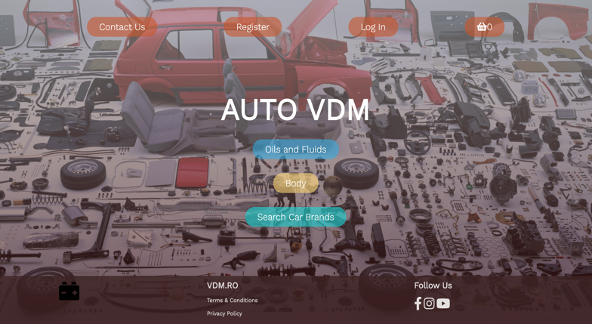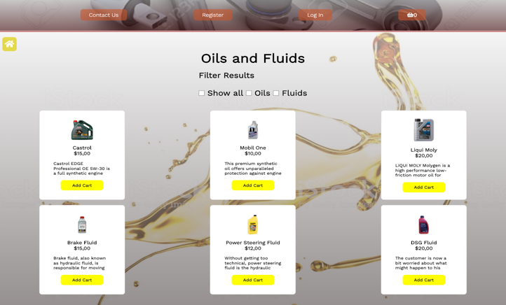

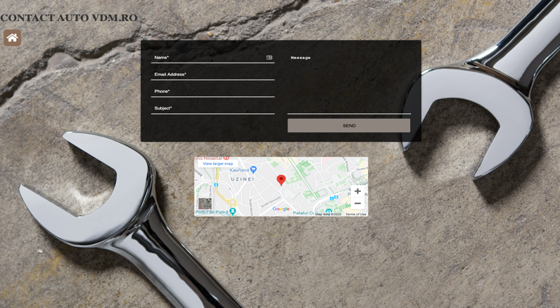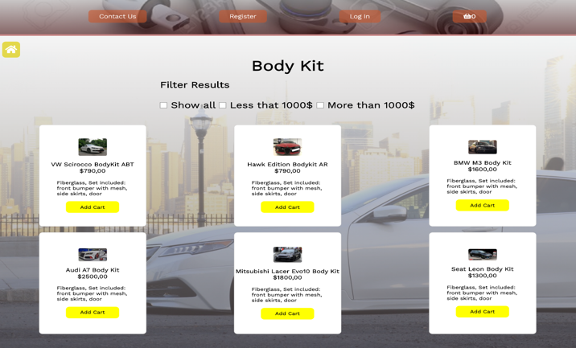

Website Introduction

Website pages are design to be easy access from any device mobile, tablet or desktop with slightly differences between them for a more user friendly interaction. I have used Google Fonts, Fontawesome and Ionicons in this project for a better design interaction.

Home Page

This home page that starts with a navigation bar with four links that are used to access the Contact Us, Register, Log In and Cart page.

The second part of it contains the Website name and three links used to access the products pages.

Last part of this page contains a footer with the Website logo, Terms & Conditions, Privacy Policy and three Follow us Icons using font awesome that will redirect you to social pages.

Contact Us

The contact us page contains on the left hand side the title followed by a link that will redirect the user once it will hit it to home page. This link has been designed with Fontawsome and CSS.

In the middle of the browser page I have designed an contact us form designed with CSS to be interactive with any resolution. The lay out of this contact form will change to a single column with multiple rows once the webpage with will be lower than 600px.

Under this Contact form I have a map that displays the location of the Auto Shop. The Google Map is inserted using a script generated by google and design in CSS.

Register Form and Log In Pages

I have designed this two pages with form format and JavaScript in order to have a method of validation and designed with CSS.

The register form page contains on the left hand side a link that will redirect the user once it will hit it to home page and the form with 7 fields that will need to validate before submitting. An error will display if the field is incorrectly completed. With JavaScript I have made this set of validation rules. For example the password needs to contain a lower, a capital, a special character & a number and the minimum of characters are 6.

Oils and Fluids, Body Kit Pages

This pages contains the same navigation bar as the home one for an easy access to the rest of the website followed by the home page link.

I have implemented a filter results list used for Oils or Filters and Less than 1000$ or More than 1000$. For this I have created a set of JavaScript functions and rules that will work with HTML classes to filter this products.

The rest of the page contains the products displayed in grid format. I have crated this grid responsive if the browser page will change his width and from two rows and three columns will have three rows and two columns. Each product has and image, title, price, product description only available for tablet or desktop with a scroll function and a add to cart button. When this button is hit the product will land in the cart page and it will show how many of them are in the navigation next to the cart symbol. If we refresh the page they will still remain in cart as the products will use Local Storage. This products pages are using JavaScript for this interactivity and functionality.

Cart Page

This page contains the same navigation bar as the home one for an easy access to the rest of the website followed by the home page link.

When the products are added to the cart from one of the previous pages they will be displayed here. Each product is split up by a thin line for a better interactivity. The added product will contain an ionicon used to remove the product from the cart and from the local storage the product image, title, price, two ionicons used for increase or decrease the amount of products and total. This products pages are using JavaScript for this interactivity and functionality.

HTML

Creating this project I have practice the standard markup language under name Hypertext Markup Language. It can be assisted by technologies such as Cascading Style Sheets (CSS) and scripting languages such as JavaScript. Web browsers receive HTML documents from a web server or from local storage and render the documents into multimedia web pages. HTML describes the structure of a web page semantically and originally included cues for the appearance of the document. HTML elements are the building blocks of HTML pages. With HTML constructs, images and other objects such as interactive forms may be embedded into the rendered page. HTML provides a means to create structured documents by denoting structural semantics for text such as headings, paragraphs, lists, links, quotes and other items. HTML elements are delineated by tags, written using angle brackets. Tags such as <img /> and <input /> directly introduce content into the page. Other tags such as <p> surround and provide information about document text and may include other tags as sub-elements. Browsers do not display the HTML tags, but use them to interpret the content of the page. HTML can embed programs written in a scripting language such as JavaScript, which affects the behavior and content of web pages. Inclusion of CSS defines the look and layout of content. The World Wide Web Consortium (W3C), former maintainer of the HTML and current maintainer of the CSS standards, has encouraged the use of CSS over explicit presentational HTML since 1997.

CSS

Cascading Style Sheets (CSS) is a style sheet language used for describing the presentation of a document written in a markup language like HTML. CSS is a cornerstone technology of the World Wide Web, alongside HTML and JavaScript. CSS is designed to enable the separation of presentation and content, including layout, colors, and fonts. This separation can improve content accessibility, provide more flexibility and control in the specification of presentation characteristics, enable multiple web pages to share formatting by specifying the relevant CSS in a separate .css file, and reduce complexity and repetition in the structural content. Separation of formatting and content also makes it feasible to present the same markup page in different styles for different rendering methods, such as on-screen, in print, by voice (via speech-based browser or screen reader), and on Braille-based tactile devices. CSS also has rules for alternate formatting if the content is accessed on a mobile device. The name cascading comes from the specified priority scheme to determine which style rule applies if more than one rule matches a particular element. This cascading priority scheme is predictable.

JavaScript

JavaScript often abbreviated as JS, is a programming language that conforms to the ECMAScript specification. JavaScript is high-level, often just-in-time compiled, and multi-paradigm. It has curly-bracket syntax, dynamic typing, prototype-based object-orientation, and first-class functions. Alongside HTML and CSS, JavaScript is one of the core technologies of the World Wide Web. JavaScript enables interactive web pages and is an essential part of web applications. The vast majority of websites use it for client-side page behavior, and all major web browsers have a dedicated JavaScript engine to execute it. As a multi-paradigm language, JavaScript supports event-driven, functional, and imperative programming styles. It has application programming interfaces (APIs) for working with text, dates, regular expressions, standard data structures, and the Document Object Model (DOM). However, the language itself does not include any input/output (I/O), such as networking, storage, or graphics facilities, as the host environment (usually a web browser) provides those APIs. JavaScript engines were originally used only in web browsers, but they are now embedded in some servers, usually via Node.js. They are also embedded in a variety of applications created with frameworks such as Electron and Cordova. Although there are similarities between JavaScript and Java, including language name, syntax, and respective standard libraries, the two languages are distinct and differ greatly in design.

Bibliography

This project was done with the knowledge leaned throw the entire course at Wantsome Academy with the help of our two mentors.

The websites used for helping me to create some parts of the project are listed bellow:

-https://javascript.info/

- <https://developer.mozilla.org/en-US/>

- <https://htmldog.com/references/css/selectors/>

- <https://css-tricks.com/>

- <https://www.w3schools.com/>

- <https://www.pexels.com/>

- <https://stackoverflow.com/>

- <https://www.freecodecamp.org/>